Daychecker Documentation
William Seeley
September 22, 2020
Southern New Hampshire University
CS-499-Q1529 Computer Science Capstone 20EW1

Daychecker Documentation
The daychecker Java file was from IT-145, which looks like is from May of 2016 – one of my first classes at SNHU when I was initially starting in my A.S. Information Technology. It requests a day of the week from the user and a number of days in the future to look. It will then return what day of the week that future day will be, as well as the day prior, the day after, and two days after. I chose this project because it was one of the few final projects that were actually written by me entirely from scratch rather than including any boiler plate code to work from. For the enhancement, I planned to rewrite the program in Python.
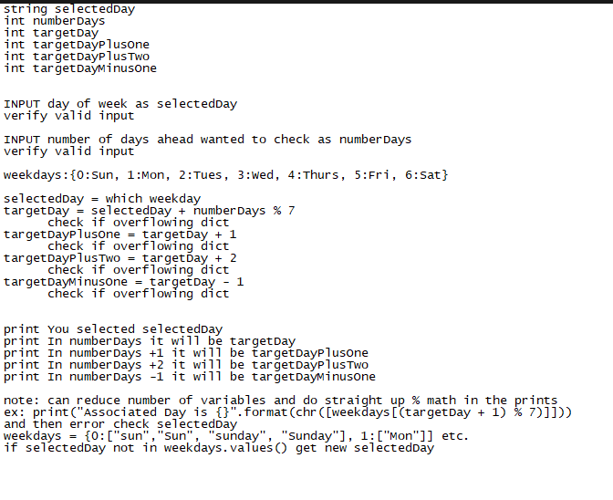
I assumed it would be fairly simple to rewrite when there is source code available to use as a reference. It wasn’t as easy as that. Doing the code review and writing the subsequent pseudo code, I wanted to move away from functions and simplify. This proved to be problematic and took a long time to actually figure out why – the original concepts of writing the code would work fine when I was working at a Python prompt, but when I saved it as a .py and tried running it as a .py file, it wasn’t liking arrays nor strings with multiple concatenations. As an example, the code in Figure 2 would work as expected at a Python prompt
Figure 2 – works in Python environment, not .py
Figure 1 - Pseudo Code
but from a .py file would report errors mixing strings and integers in a print. I originally had the days of week in a dictionary and so went through many different avenues of approach thinking it had something to do with the dictionary. I finally started re-evaluating all the basic assumptions and learned it was the initial concatenation that was the error, not the second.
Figure 3 -- works in both Python and .py

In retrospect, I assume there are modules pip installed into the environment which is why the prompt is working differently than the .py file. The only module I know for certain that is installed is scapy for converting hex data into byte stream during some of our pcap challenges in the Cyberleague, but it is an old environment that may very well have other modules installed and forgotten. That is probably the biggest lesson learned: that my own Python environment is not the same playground if I’m writing .py files to be redistributed.

